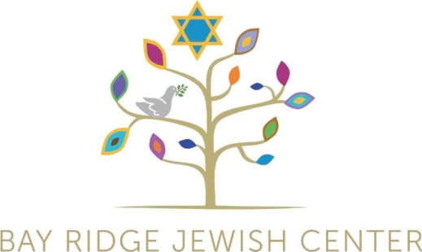
BAY RIDGE JEWISH CENTER
Congregation Sheiris Israel
405 81st Street Brooklyn, New York 11209
Phone: 718-836-3103 / Fax: 718-745-4365
office@brjc.org / www.brjc.org
hebrewschool@brjc.org

Hebrew School
New & Returning Student Registration

5786 School Year:
September 10th, 2025 through June 17th, 2026
Wednesdays, 4-6 p.m.

Please use one form for each student.

Student Name: _______________________Hebrew Name: _____________________

Birthdate: _________________ School: __________________ Grade: ____________

Parent/Guardian #1:

Name: _______________________________________________________________

Address: _____________________________________________________________

Phone: ____________________________________________ OK to Text? (Yes/No)

E-mail: _____________________________________ We send weekly announcements.

Parent/Guardian #2:

Name: _______________________________________________________________

Address: _____________________________________________________________

Phone: ____________________________________________ OK to Text? (Yes/No)

E-mail: _____________________________________ We send weekly announcements.

Medical:
Please describe any conditions, medications, or allergies that we should be aware of.

If medical attention is needed during school time, how would you like us to handle it?

Attention/Emotional:
Please describe any learning challenges your child has such as paying attention (e.g. ADHD) or interacting with other students (e.g. sensitivity).

Emergency Contact #1:

Name: ______________________________________________________________

Phone: ____________________________________Relationship________________

Emergency Contact #2:

Name: ______________________________________________________________

Phone: ___________________________________ Relationship:________________

Permissions:

- Who can pick up your child from Hebrew School?

Name: ______________________________________________________________

Phone: ___________________________________ Relationship:________________

Name: ______________________________________________________________

Phone: ___________________________________ Relationship:________________

- My child’s name may appear on the Hebrew School’s roster, website, or other printed/electronic material created by the synagogue. (Yes/No)

- My child’s picture (without a name attached) may appear on BRJC’s website or
other printed/electronic material created by the synagogue. (Yes/No)

- Bay Ridge Jewish Center has my permission to handle Medical Emergencies as
deemed necessary.

Parent’s Signature: ____________________________________ Date: ____________

Other Comments
Is there any other information you would like us to know?

Cost of Hebrew School:

Annual Tuition per Student: $1,100

Policies

All Hebrew School families are required to be members of Bay Ridge Jewish Center.
Separate membership fees apply.

Registration forms and tuition payments must be completed prior to attending Hebrew School.

Once you send in your application, we will be in touch with you to make the financial arrangements. Payment plans and special arrangements based on financial hardship are available. For more information contact us [president@brjc.org]. All discussions are confidential.

Thank you for enrolling your child in BRJC’s Hebrew School!
We are glad that your child and family will be a part of our community this year.
If you have any questions, please reach out by e-mail: hebrewschool@brjc.org.

